

**Project Name:** **FOOD DELIVERY MANAGEMENT SYSTEM.**

Group Members Name & ID:

|  |
| --- |
| Name |
| **Tania Kamrun Nahar** |
| **Zeba, Sehrish** |
| **Arifuzzman** |
| **Era, Israt Yeasin** |
| **Hossain, Lokman** |
| **Misu, MD. Murad Alahi** |

**Course Name: Introduction to Database.**

**Section: H**

**Content’s:**

|  |  |
| --- | --- |
| **Topics** | **Pages** |
| **1. Introduction of the project.** | **3** |
| **2. Scenario Description.** | **4-5** |
| **3. ER –Diagram Drawing.** | **5** |
| **4. Normalization.** | **6-14** |
| **5. Schema Diagram.** | **14** |
| **6. Table Creation.** | **15-29** |
| **7. Data Insertion.** | **29-46** |
| **8. Query Writing.** | **46-50** |
| **9. Relational Algebra.** | **51** |
| **10. Conclusion.** | **52** |

**Introduction:**

Food is always a vital element in our life to survive. When one can get food easily in his/her door, life gets easier. Food delivery system is such a medium by which we can get food easily at our doorstep. In this system the owner has to maintain a database to run the Food delivery system smoothly. There are some of the factors that a database creator needs to focus while creating the database. In food delivery application, database system has to be set up neatly to maintain location of restaurants, restaurants’ food items, delivery details, payment methods, customers’ details etc. This system has been set up to manage all those necessities all in combine.

**Scenario Description:**

Firstly, in a food delivery management system a subscribed customer can order from any restaurant. One can order one or multiple items from any one restaurant at a time which defines one to many relationship. This system is accustomed to store customer contact details and address. A customer details section is comprised of customer name, id, phone number, email and delivery address while customer delivery address is consisted of house number, road number and block number. A restaurant is identified by restaurant details that is stored of area, name, phone number, email and address. While ordering food, the customer has to choose one restaurant and the order details is recorded that includes order id, track of order, number of items and total bill. One restaurant can take multiple orders at a time that states one to many relationship with order. An order is recorded when the customer chooses the food item. A food is composed of name, price, number of items and name. An order can have multiple number of food items that defines one to many relationship. After setting the order, the customer has to confirm the payment method. A payment method can have various options- cash on delivery, visa, bikash, rocket. This also is defined as one to many relationship. After confirmation, a restaurant passes the selected food item(s) to the delivery boy according to the order id and the customer id. Every delivery boy has an individual detail that is consisted of delivery man name, id and phone number. There is many to many relationship between delivery boy and restaurant. One delivery boy can have multiple number of food items that states one to many relationship between them.

**ER-Diagram:**

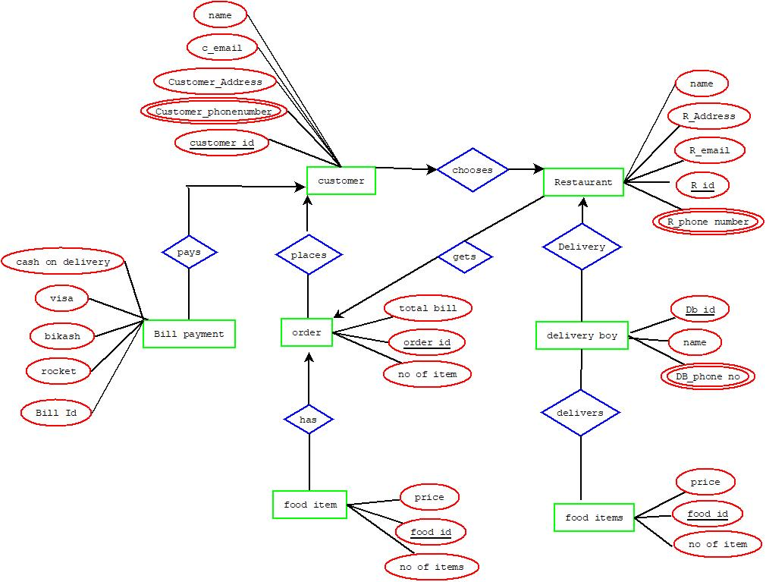

**Normalization:**

**Pays:**

**Unf:**

(customer_id, name, email, Address, c_phonenumber, cash_on_delivery, visa, bikash, rocket, bill id)

**1st NF:**

Phonenumber is multivalued.

1. name, email, Address, customer_id, cash_on_delivery, visa, bikash, rocket, bill id

**2nd NF:**

1. name, email, Address, phonenumber, customer_id

2. cash_on_delivery, visa, bikash, rocket, bill id

3rd NF

There is no transitive dependency.

**Table creation:**

1. customer_id, bill_id

2.name, email, Address, c­­_phonenumber, customer_id

3.cash on delivery, visa, bikash, rocket, bill id

4. c_phonenumber_id, c_phonenumber

**Places:**

**unf:**

(name,email, address, phonenumber, customer_id, total bill, order_id,no_of_item, delivery_phonenumber)

**1st NF:**

delivery­_phonenumber,

phonenumber is the multivalued.

1. total bill,Order_id, no of item,name,email,Address, customer_id

**2nd Nf:**

1. email,address,phonenumber,customer_id

2. total bill,order_id,no of item,deliveryphonenumber

**3rd nf:**

1. There is no transitive dependency

**Table creation:**

1. order_id,customer_id, place_id

2. total bill,order_id,no_of_item,delivery_phone_no

3. phonenumber,phonenumber_id

4. delivery_phoneno_id, delivery_phone_no

**Has:**

**unf**

(total bill,Order_id, no of item,deliveryphoneno,price,food_id,no of item)

**1st NF:**

delivery phone number is the multivalued.

1. bill,Order_id, no of item ,price,food_id,no of item

**2nd NF:**

1. total bill,Order_id, no of item,deliveryphoneno

2. price, food_id,no of item

**3rd NF:**

There is no transitive dependency

**Table creation:**

1. total bill,order_id, no of item,delivery_phone_no

2. delivery_phoneno_id, delivery_phone_no

3. price,food_id,no of item

4.h_id, order_id, food_id

**Choose:**

**unf:**

(name,email,address,C_phonenumber,customer_id,name,address, email,R_id,R_phonenumber)

**1st NF:**

C_phonenumber,R_phonenumber is the maltivalue

1. name,email,address,C_phonenumber,customer_id,name,address email,R_id,R_phonenumber

**2nd NF:**

1. name,email,address,C_phonenumber,customer_id

2. name,address email,R_id,R_phonenumber

**3rd nf:**

There is no transitive dependency.

**Table creation:**

1. c_id,name,email,address,c_phonenumber

2. name,address email,R_phonenumber

3. R_phonenumberid, R_phonenumber

4. c_id, customer_id, R_id

**Gets:**

**UNF:**

(name,address, email,R_id,R_phonenumber, total bill,Order_id, no of item,deliveryphoneno)

**1st NF:**

R_phonenumber, deliveryphoneno is the multivalued

1. name,address, email,R_id, total bill,Order_id, no of item

**2nd NF:**

1. name,address, email,R_id,R_phonenumber

2. total bill,Order_id, no of item,deliveryphoneno

**3rd NF:**

There is no transitive dependency:

**Table creation:**

1. name,address, email,R_id,R_phonenumber

2. total bill,order_id, no of item,delivery_phone_no

3. delivery_phoneno_id, delivery_phone_no

4. gets_id, R_id, order_id

**hires:**

**UNF:**

( name,address email,R_phonenumber,R_ID,name,db_ID,Db_phonenumber)

**1st nf:**

1.R_phonenumber,DB_phonenumber is maltivalue

name,address email,R_ID,name,db_ID,

**2nd nf:**

1. name,address email,R_phonenumber,R_id

2.name,db_id,db_phonenumber

**3rd nf:**

there is no transitive dependency

**Table creation:**

1. name,address email,R_phonenumber,r_id

2. name,db_id,db_phonenumber

3. db_phonenumber_id, db_phonenumber

4. db_id, r_id, hires_id

**delivers:**

**UNF:**

(name,DB_ID,DB_Phonenumber,Price,Food_id,No of item)

**1st NF:**

DB_phonenumber is the multivalue

1. name,DB_ID ,Price,Food_id,No of item

**2nd NF:**

1. name,DB_ID,DB_Phonenumber

2. Price,Food_id,No of item

**3rd NF:**

There is no transitive dependency.

**Table creation:**

1. delivers_id, db_id, food_id

2. price,food_id,no of item

3. name,db_id,db_phonenumber

4.. db_phonenumber_id, db_phonenumber

**Final tables:**

1. name, email, Address, c­­ustomer_phonenumber, customer_id

2. customer_phonenumber_id,customer_phonenumber

3. cash_on_delivery, visa, bikash, rocket, bill id

4. customer_id, bill_id, pays_id

5. total bill,order_id,no_of_item

6. order_id,customer_id, place_id

7. price,food_id,no of item

8.has_id, order_id, food_id

9. R_id ,name,address email,R_phonenumber

10. R_phonenumberid, R_phonenumber

11. choose_id, customer_id, R_id

12. gets_id, R_id, order_id

13. name,db_id,db_phonenumber

14. db_phonenumber_id, db_phonenumber

15. db_id, r_id, hires_id

16. deliver_id, db_id, food_id

**Schema Diagram:**

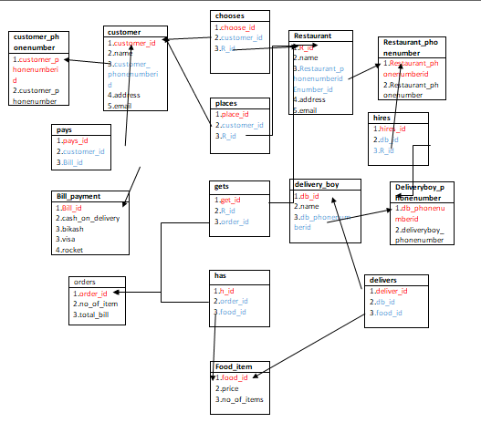

**Tables Creation:**

1.CREATE TABLE customer(customer_id number(3)primary key, name varchar(15),email varchar(20),address varchar(20),customer_phonenumberid number);

ALTER TABLE customer add constraint Fok1 foreign key(customer_phonenumberid) references customer_phonenumber1(customer_phonenumberid);

2.CREATE TABLE customer_phonenumber(customer_phonenumberid number(3)primary key,customer_phonenumber number);

3.CREATE TABLE Bill_payment(bill_id number(3)primary key,cash_on_delivery number(5),visa number(5),bikash number(5),rocket number(5));

4.CREATE TABLE pays( pays_id number(3)primary key,customer_id number(3),bill_id number(3));

ALTER TABLE pays add constraint Fok2 foreign key(customer_id) references customer(customer_id);

ALTER TABLE pays add constraint Fok3 foreign key(bill_id) references Bill_payment(bill_id);

5. CREATE TABLE orders(order_id number(3)primary key,no_of_item number(3),total_bill number(5));

6.CREATE TABLE places(place_id number(3)primary key,customer_id number(3),order_id number(3));

ALTER TABLE places add constraint Fok5 foreign key(customer_id) references customer(customer_id);

ALTER TABLE places add constraint Fok6 foreign key(order_id) references orders(order_id);

7.CREATE TABLE food_item(food_id number(3) primary key, price number,no_of_items number(5));

8.CREATE TABLE has(h_id number(3),order_id number(3),food_id number(3));

ALTER TABLE has add constraint Fok7 foreign key(order_id) references orders(order_id);

ALTER TABLE has add constraint Fok8 foreign key(food_id) references food_item(food_id);

9.CREATE TABLE Restaurant(R_id number(3)primary key,name varchar(15),address varchar(20),email varchar(20),Restaurant_phonenumberid number(3));

ALTER TABLE Restaurant add constraint Fok9 foreign key(Restaurant_phonenumberid) references Restaurant_phonenumber(Restaurant_phonenumberid);

10.CREATE TABLE Restaurant_phonenumber(Restaurant_phonenumberid number(3)primary key, Restaurant_phonenumber number);

11.CREATE TABLE chooses(choose_id number(3)primary key,customer_id number(3),R_id number(3));

ALTER TABLE chooses add constraint Fok10 foreign key(customer_id) references customer(customer_id);

ALTER TABLE chooses add constraint Fok11 foreign key(R_id) references Restaurant(R_id);

12.CREATE TABLE gets(get_id number(3)primary key,R_id number(3), order_id number(3));

ALTER TABLE gets add constraint Fok12 foreign key(R_id) references Restaurant(R_id);

ALTER TABLE gets add constraint Fok13 foreign key(order_id) references orders(order_id);

13.CREATE TABLE delivery_boy(db_id number(3)primary key,name varchar(15),db_phonenumberid number);

ALTER TABLE delivery_boy add constraint Fok14 foreign key(db_phonenumberid) references deliveryboy_phonenumber(db_phonenumberid);

14.CREATE TABLE deliveryboy_phonenumber(db_phonenumberid number(3)primary key,db_phonenumber number);

15.CREATE TABLE hires(hires_id number(3)primary key,db_id number(3), r_id number(3));

ALTER TABLE hires add constraint Fok15 foreign key(db_id) references delivery_boy(db_id);

ALTER TABLE hires add constraint Fok16 foreign key(R_id) references Restaurant(R_id);

16.CREATE TABLE delivers(deliver_id number(3)primary key, db_id number(3), food_id number(3));

ALTER TABLE delivers add constraint Fok17 foreign key(db_id) references delivery_boy(db_id);

ALTER TABLE delivers add constraint Fok18 foreign key(food_id) references food_item(food_id);

**Describe Table:**

desc customer;

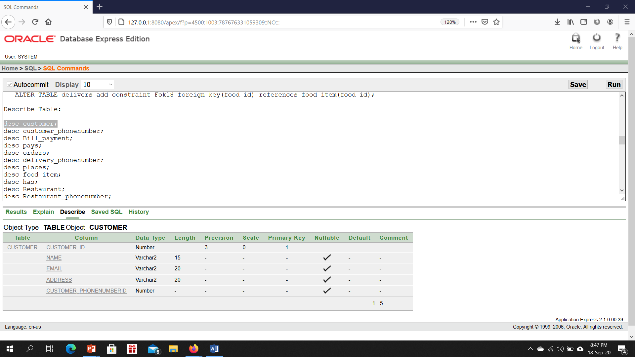

desc customer_phonenumber;

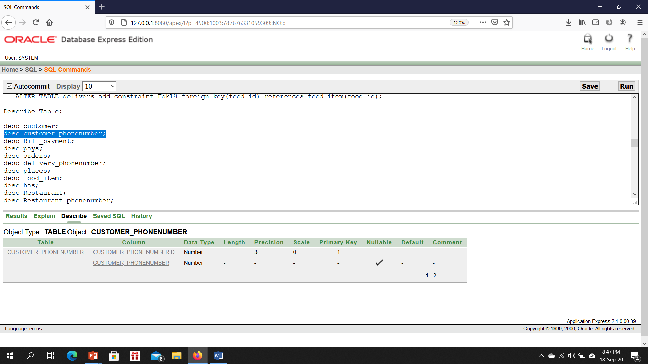

desc Bill_payment;

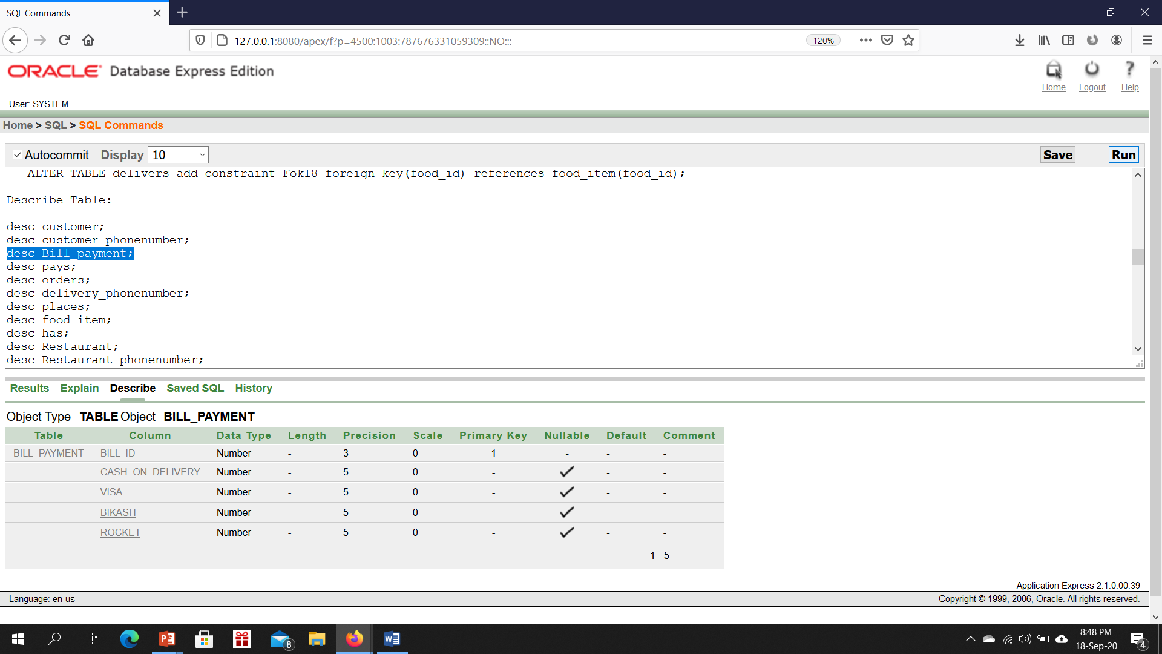

desc pays;

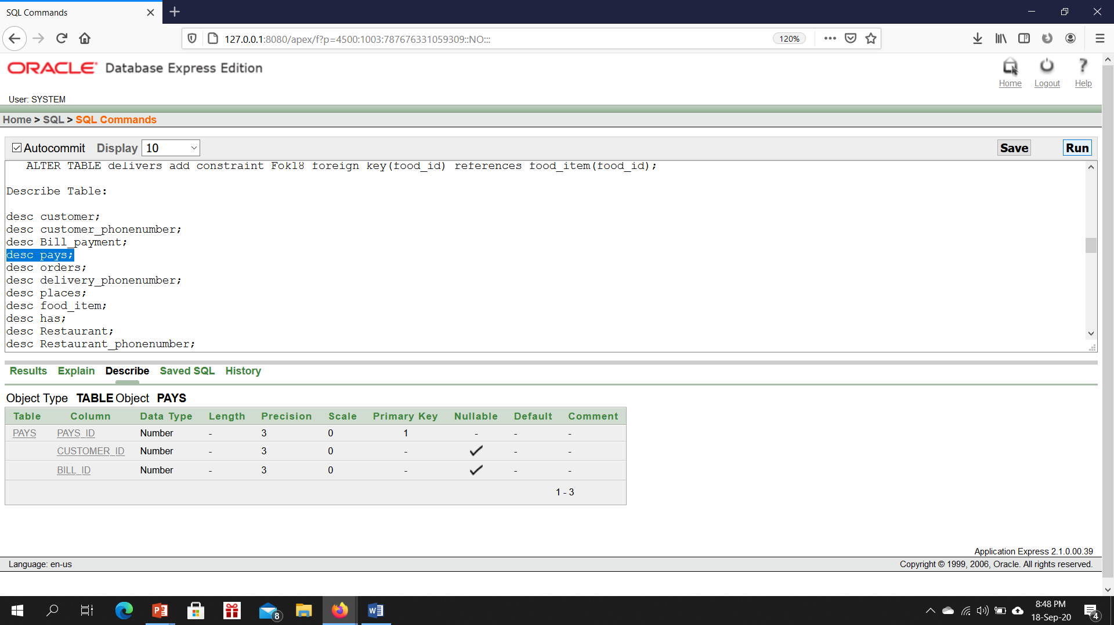

desc orders;

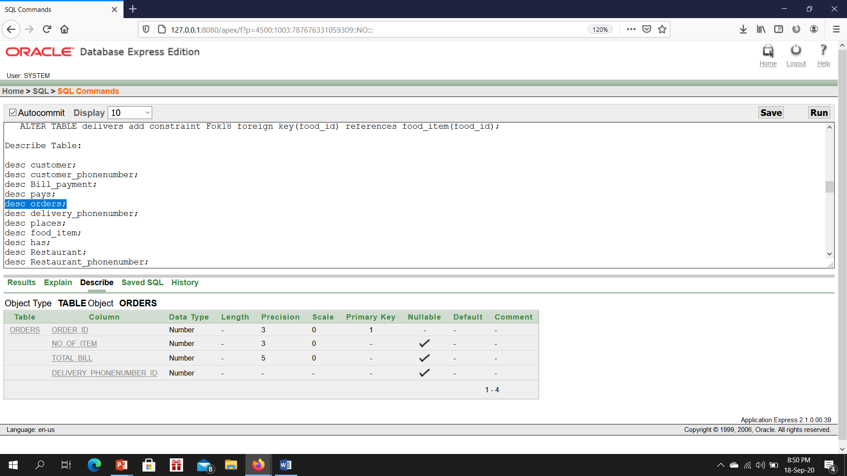

desc places;

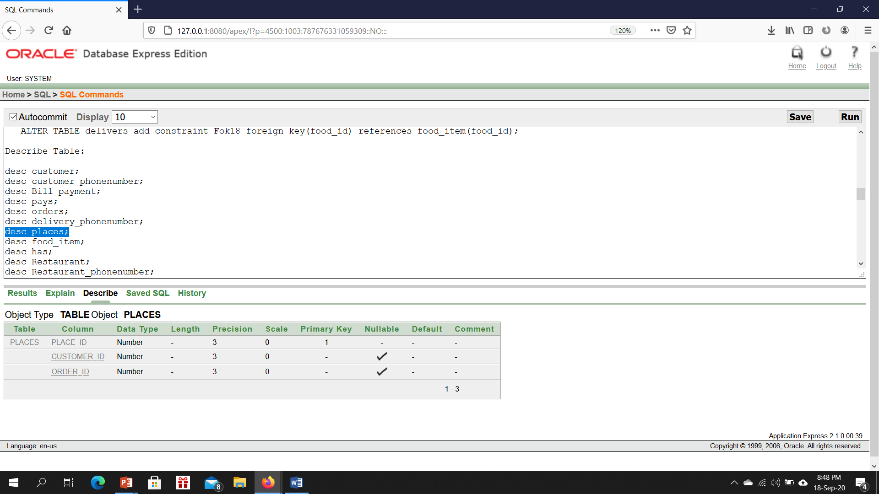

desc food_item;

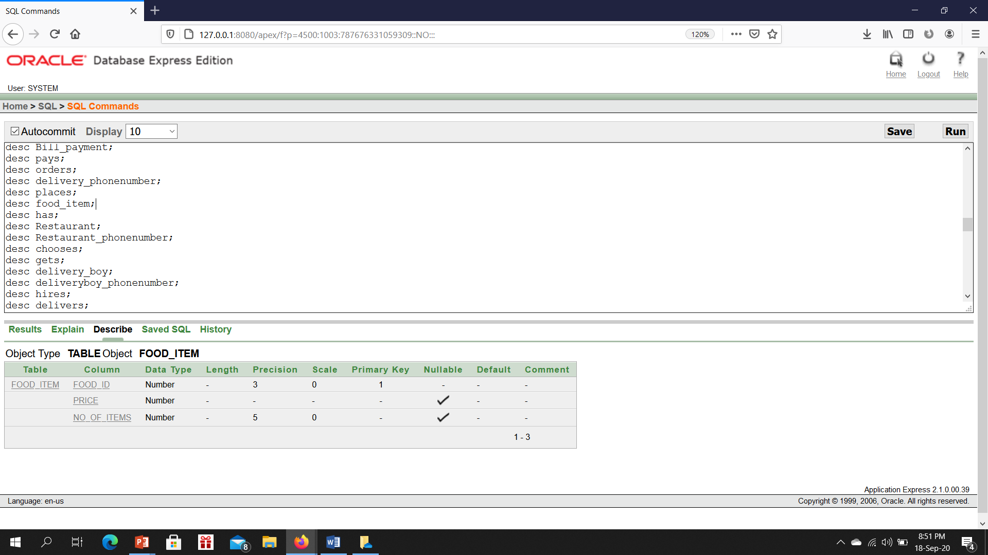

desc has;

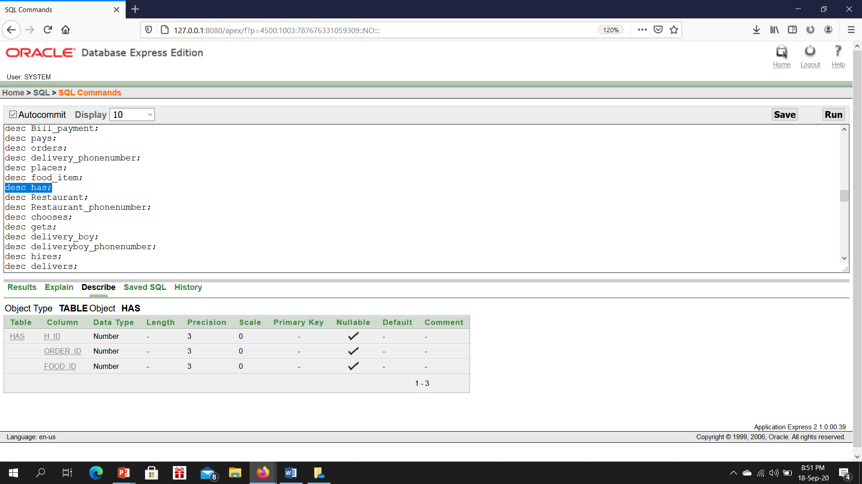

desc Restaurant;

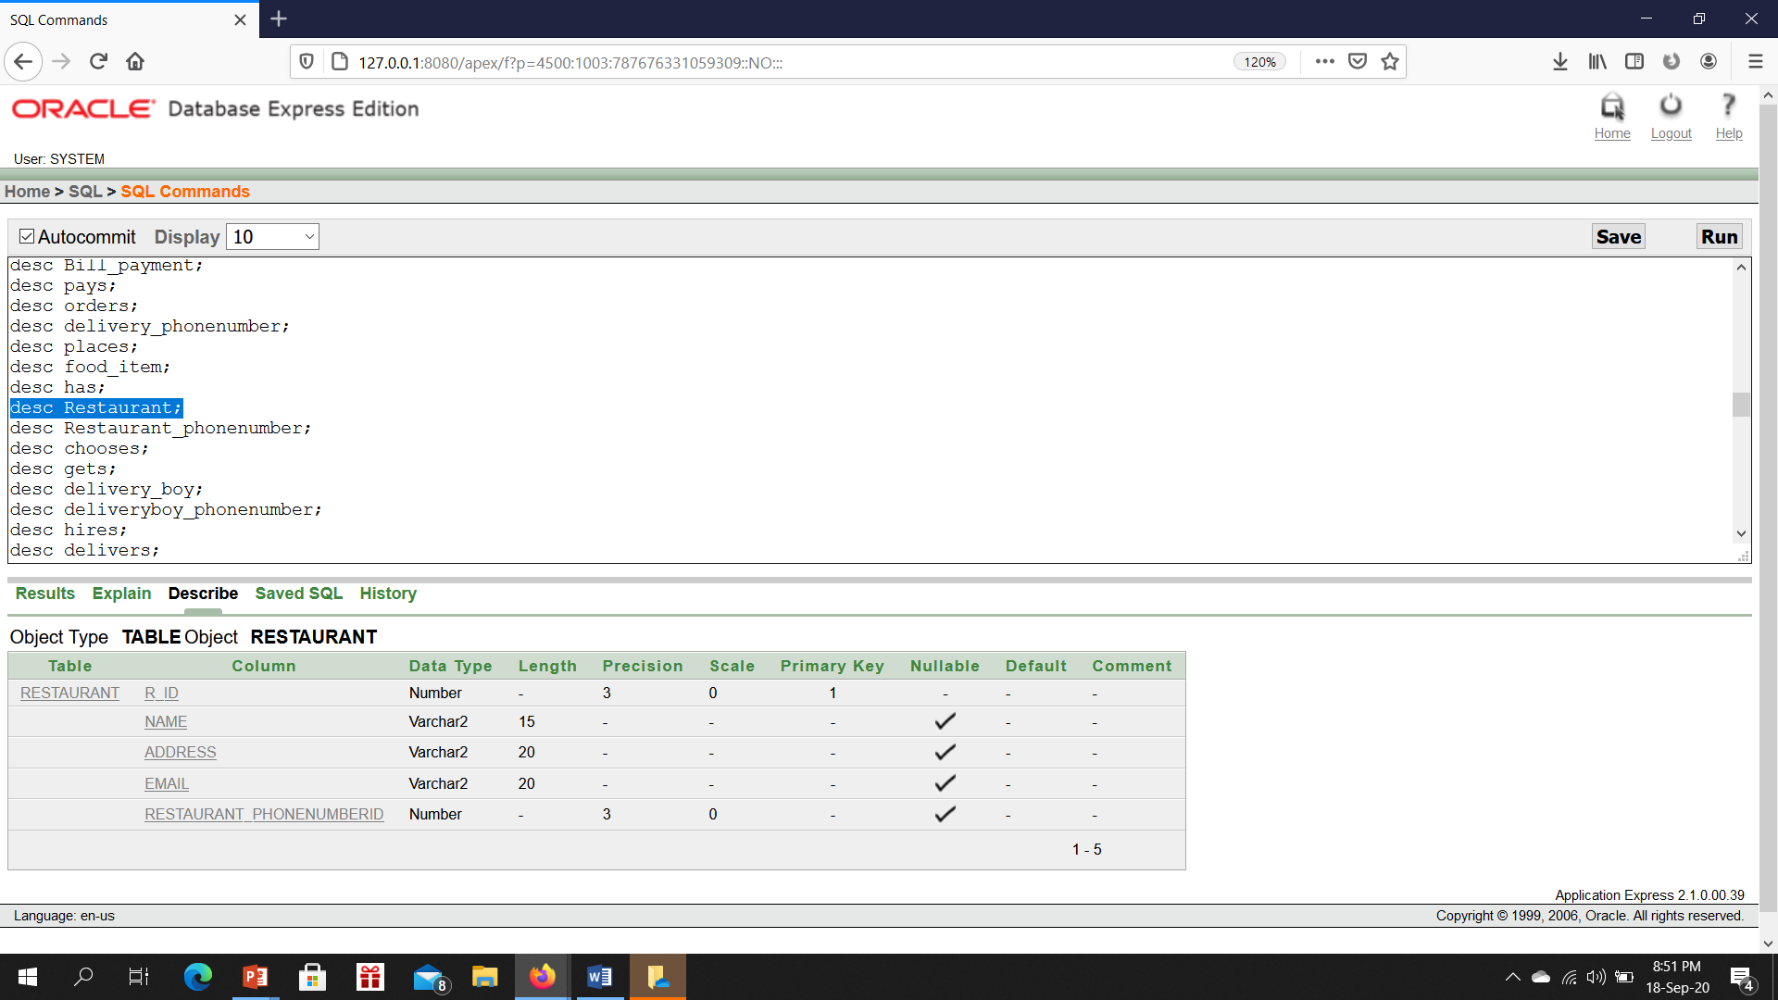

desc Restaurant_phonenumber;

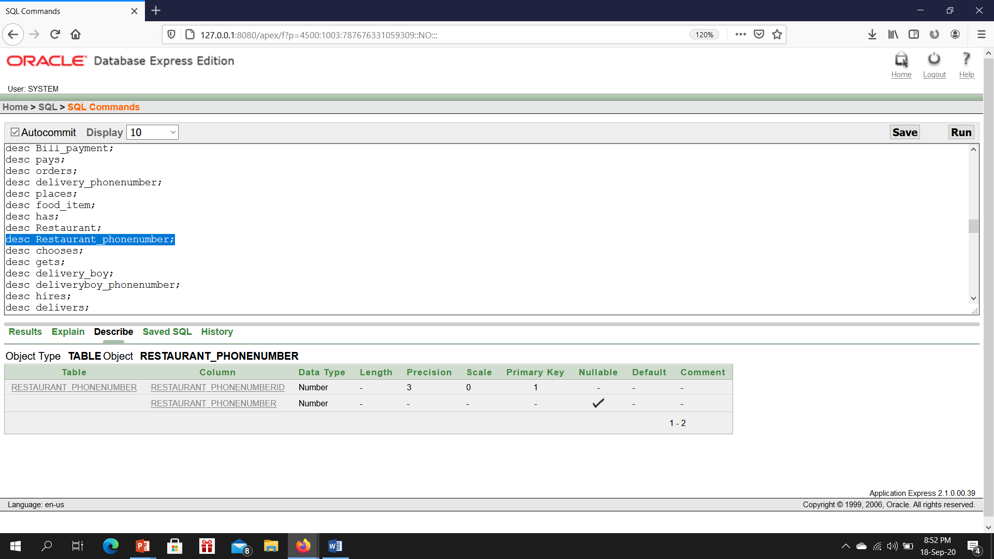

desc chooses;

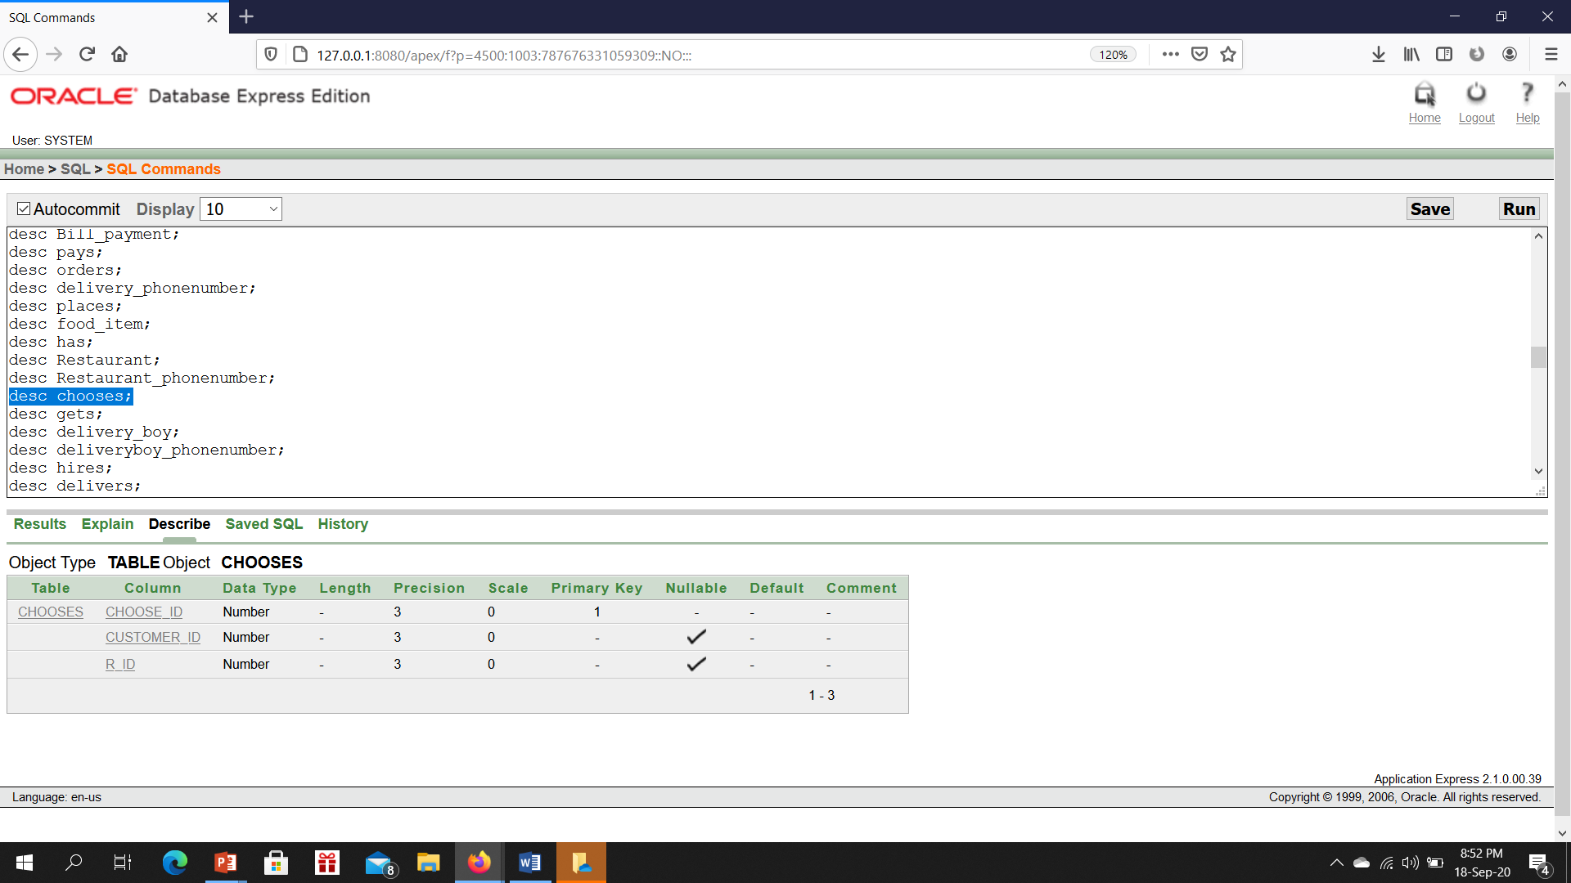

desc gets;

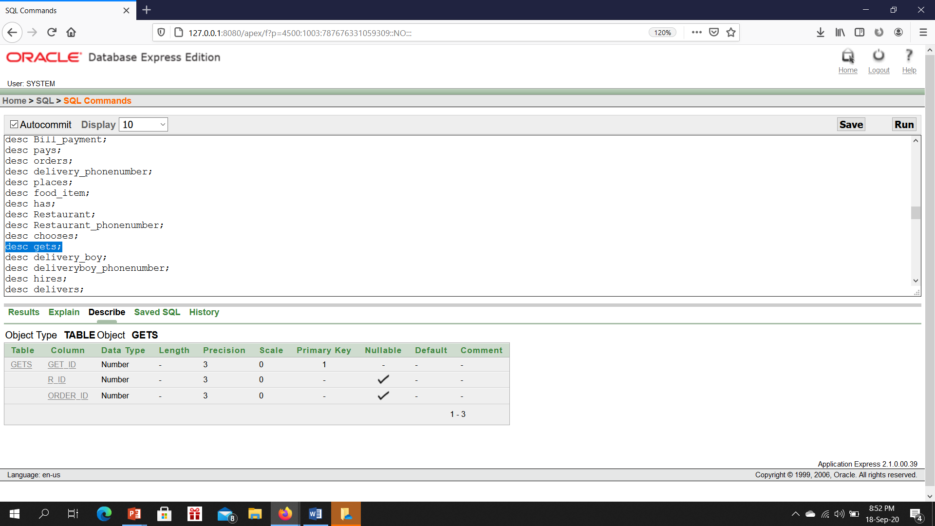

desc delivery_boy;

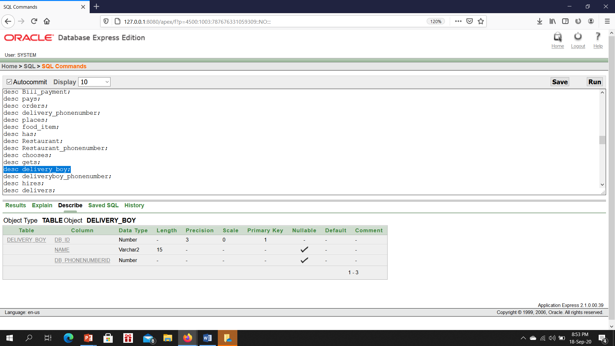

desc deliveryboy_phonenumber;

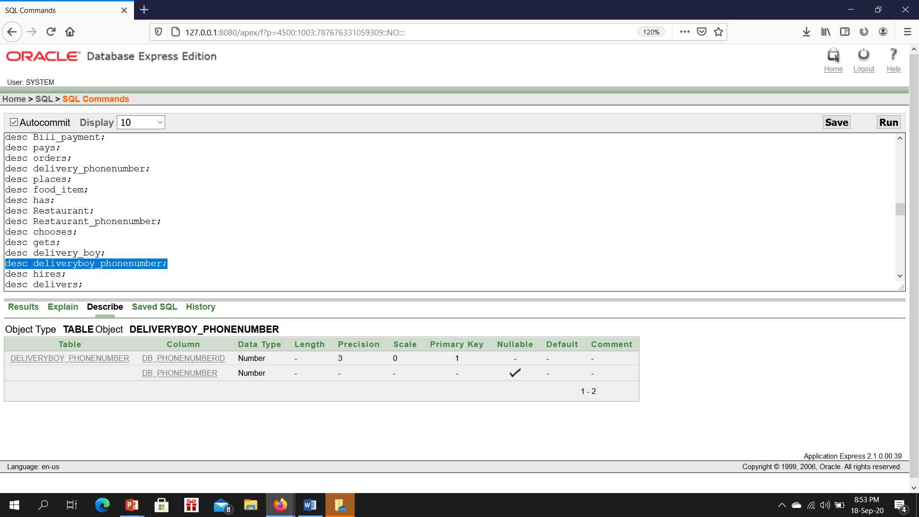

desc hires;

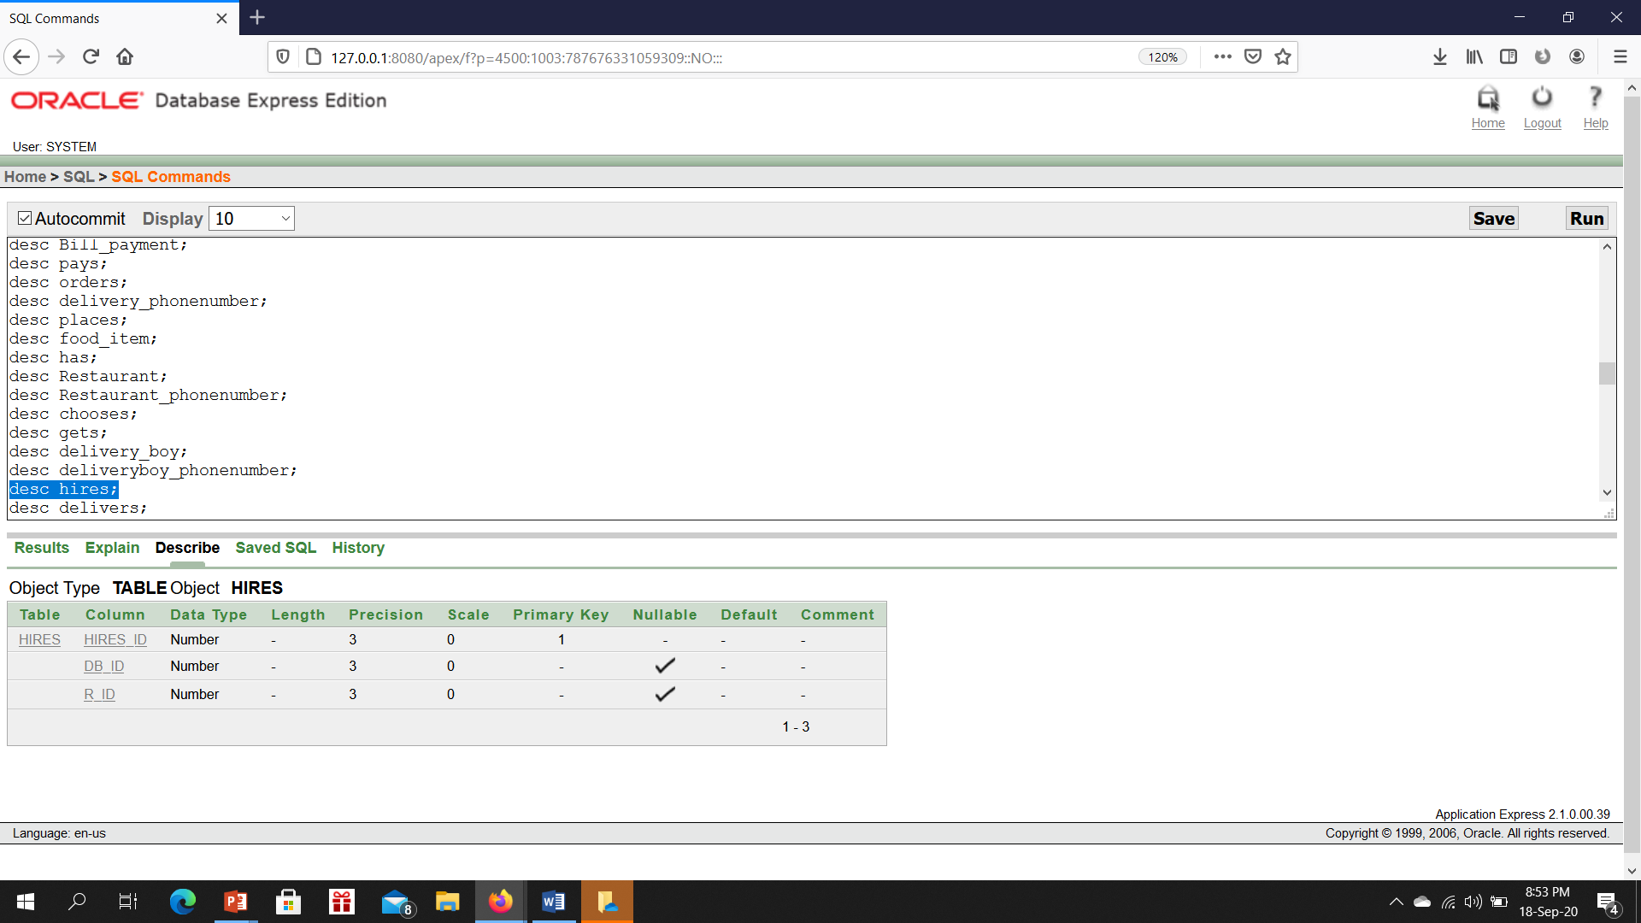

desc delivers;

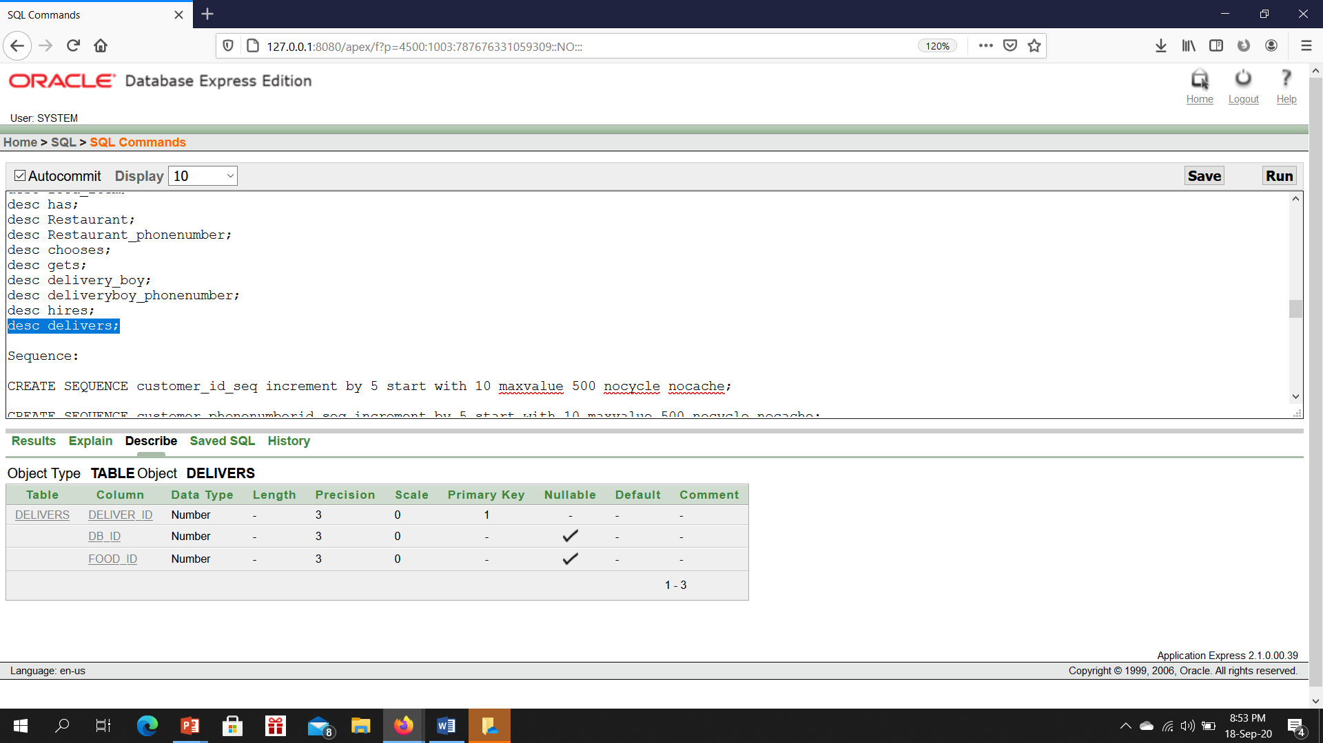

**Sequence:**

CREATE SEQUENCE customer_id_seq increment by 5 start with 10 maxvalue 500 nocycle nocache;

CREATE SEQUENCE customer_phonenumberid_seq increment by 5 start with 10 maxvalue 500 nocycle nocache;

CREATE SEQUENCE bill_id_seq increment by 5 start with 10 maxvalue 500 nocycle nocache;

CREATE SEQUENCE pays_id_seq increment by 5 start with 10 maxvalue 500 nocycle nocache;

CREATE SEQUENCE order_id_seq increment by 5 start with 10 maxvalue 500 nocycle nocache;

CREATE SEQUENCE place_id_seq increment by 5 start with 10 maxvalue 500 nocycle nocache;

CREATE SEQUENCE food_id_seq increment by 5 start with 10 maxvalue 500 nocycle nocache;

CREATE SEQUENCE h_id_seq increment by 5 start with 10 maxvalue 500 nocycle nocache;

CREATE SEQUENCE R_id_seq increment by 5 start with 10 maxvalue 500 nocycle nocache;

CREATE SEQUENCE Restaurant_phonenumberid_seq increment by 5 start with 10 maxvalue 500 nocycle nocache;

CREATE SEQUENCE choose_id_seq increment by 5 start with 10 maxvalue 500 nocycle nocache;

CREATE SEQUENCE get_id_seq increment by 5 start with 10 maxvalue 500 nocycle nocache;

CREATE SEQUENCE db_id_seq increment by 5 start with 10 maxvalue 500 nocycle nocache;

CREATE SEQUENCE db_phonenumberid_seq increment by 5 start with 10 maxvalue 500 nocycle nocache;

CREATE SEQUENCE hires_id_seq increment by 5 start with 10 maxvalue 500 nocycle nocache;

CREATE SEQUENCE deliver_id_seq increment by 5 start with 10 maxvalue 500 nocycle nocache;

**User Access Control:**

CREATE USER applicationUser identified by gyr567tz;

CREATE ROLE Food;

GRANT CREATE TABLE,CREATE VIEW,CREATE SEQUENCE,CREATE PROCEDURE TO food;

GRANT food to applicationUser;

**DATA INSERTION:**

1.CREATE TABLE customer(customer_id number(3)primary key, name varchar(15),email varchar(20),address varchar(20),customer_phonenumberid number);

desc customer;

INSERT INTO CUSTOMER VALUES(20,'john','john67@gmail.com','Dhanmondi','1');

INSERT INTO CUSTOMER VALUES(21,'smith','smith99@gmail.com','kuril','2');

INSERT INTO CUSTOMER VALUES(23,'kobe','kobe78@gmail.com','Rampura','3');

INSERT INTO CUSTOMER VALUES(25,'Nelson','nelson09@gmail.com','Mohakhali','4');

INSERT INTO CUSTOMER VALUES(27,'cairo','cairo789@gmail.com','Dhanmondi','5');

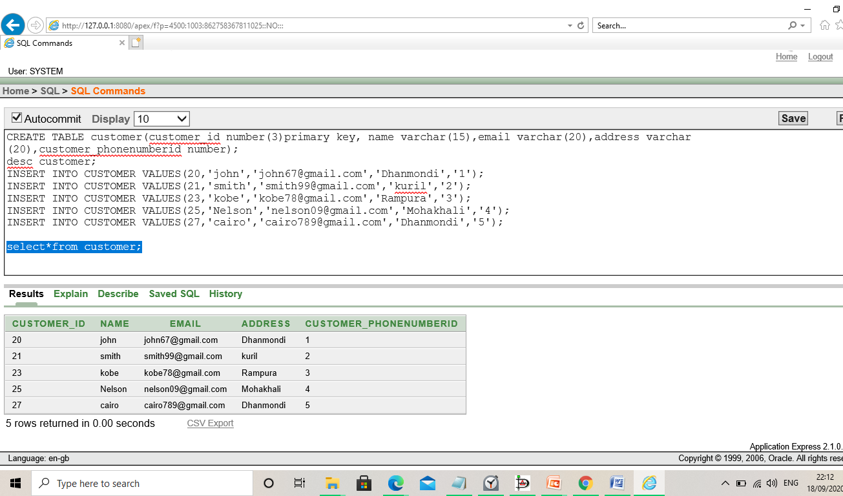

2. CREATE TABLE customer_phonenumber(customer_phonenumberid number(3)primary key,customer_phonenumber number);

DESC customer_phonenumber;

INSERT INTO CUSTOMER_PHONENUMBER VALUES(1,01992347689);

INSERT INTO CUSTOMER_PHONENUMBER VALUES(2,01992847689);

INSERT INTO CUSTOMER_PHONENUMBER VALUES(3,01892347689);

INSERT INTO CUSTOMER_PHONENUMBER VALUES(4, 01692347689);

INSERT INTO CUSTOMER_PHONENUMBER VALUES(5,01992356789);

SELECT*FROM customer_phonenumber;

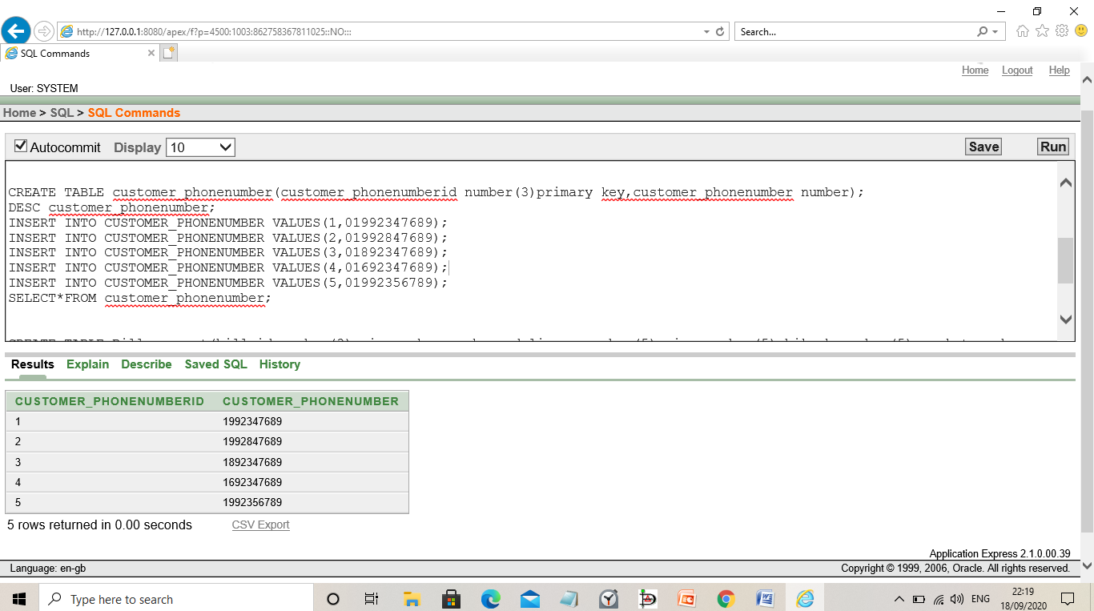

3. CREATE TABLE Bill_payment(bill_id number(3)primary key,cash_on_delivery number(5),visa number(5),bikash number(5),rocket number(5));

DESC BILL_PAYMENT;

INSERT INTO BILL_PAYMENT VALUES(12,00,00,9234,00);

INSERT INTO BILL_PAYMENT VALUES(16,4567,00,00,00);

INSERT INTO BILL_PAYMENT VALUES(19,00,00,9234,00);

INSERT INTO BILL_PAYMENT VALUES(20,00,00,00,8970);

INSERT INTO BILL_PAYMENT VALUES(72,4870,00,00,00);

SELECT*FROM Bill_payment;

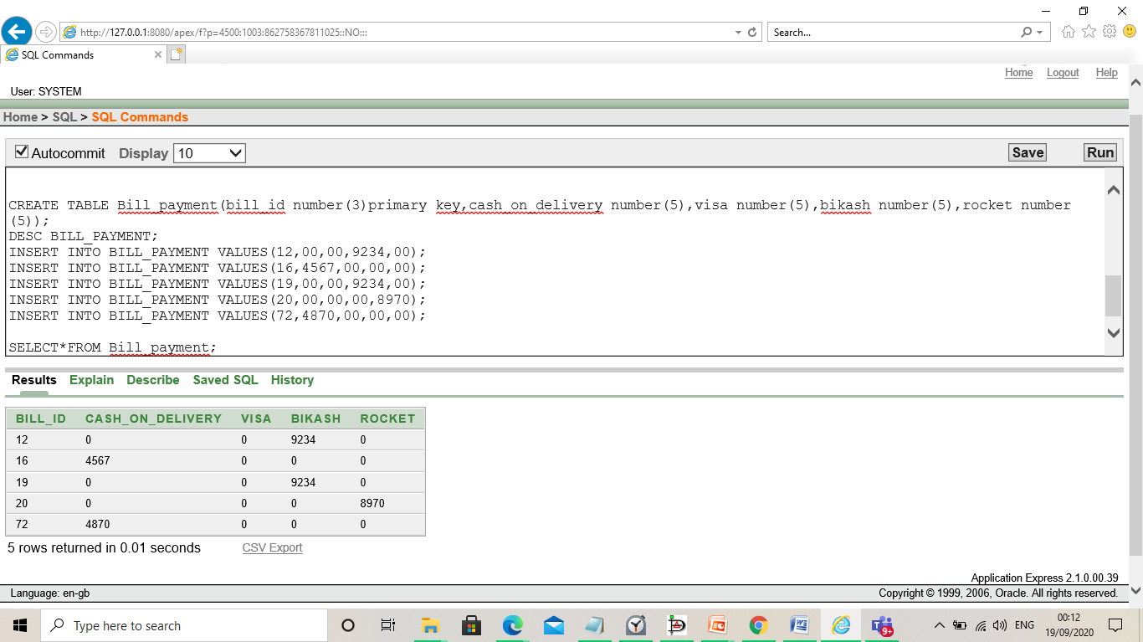

4CREATE TABLE pays( pays_id number(3)primary key,customer_id number(3),bill_id number(3));

ALTER TABLE pays add constraint Fok2 foreign key(customer_id) references customer(customer_id);

ALTER TABLE pays add constraint Fok3 foreign key(bill_id) references Bill_payment(bill_id);

DESC PAYS;

DROP TABLE PAYS;

INSERT INTO PAYS VALUES(101,20,12);

INSERT INTO PAYS VALUES(102,21,16);

INSERT INTO PAYS VALUES(103,23,19);

INSERT INTO PAYS VALUES(104,25,20);

INSERT INTO PAYS VALUES(105,27,21);

SELECT*FROM PAYS;.

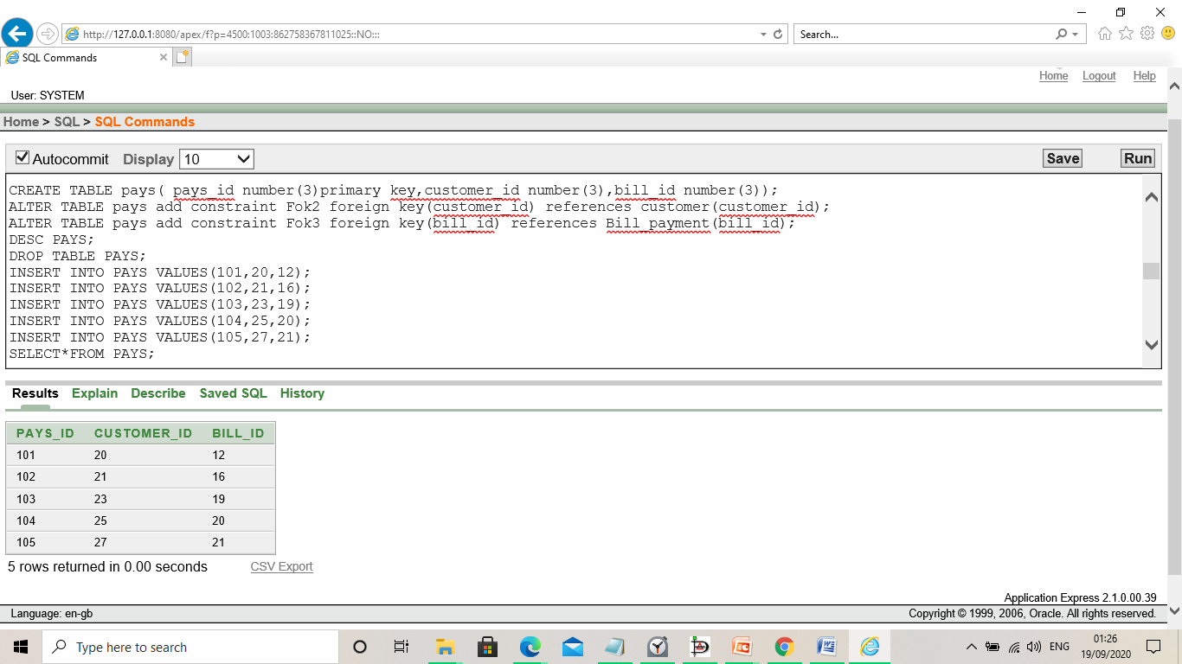

5. CREATE TABLE orders(order_id number(3)primary key,no_of_item number(3),total_bill number(5));

DESC ORDERS;

INSERT INTO ORDERS VALUES(65,3,678);

INSERT INTO ORDERS VALUES(67,4,1578);

INSERT INTO ORDERS VALUES(68,3,1678);

INSERT INTO ORDERS VALUES(69,5,978);

INSERT INTO ORDERS VALUES(70,6,1278);

SELECT*FROM ORDERS;

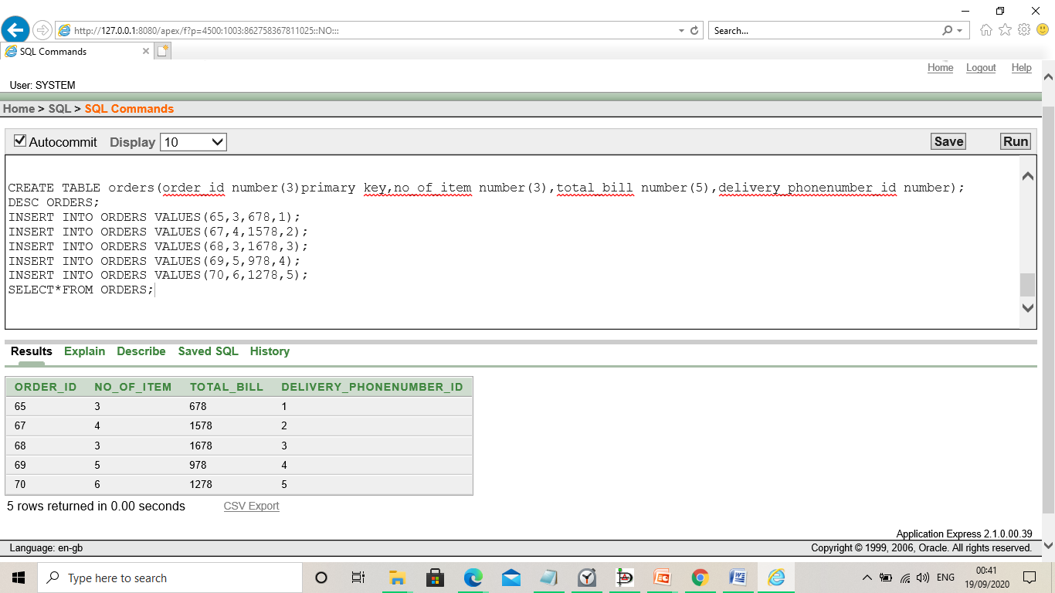

6. CREATE TABLE places(place_id number(3)primary key,customer_id number(3),order_id number(3));

ALTER TABLE places add constraint Fok5 foreign key(customer_id) references customer(customer_id);

ALTER TABLE places add constraint Fok6 foreign key(order_id) references orders(order_id);

DESC PLACES;

INSERT INTO PLACES VALUES(304,20,65);

INSERT INTO PLACES VALUES(305,21,67);

INSERT INTO PLACES VALUES(306,23,68);

INSERT INTO PLACES VALUES(307,25,69);

INSERT INTO PLACES VALUES(308,27,70);

SELECT*FROM PLACES;

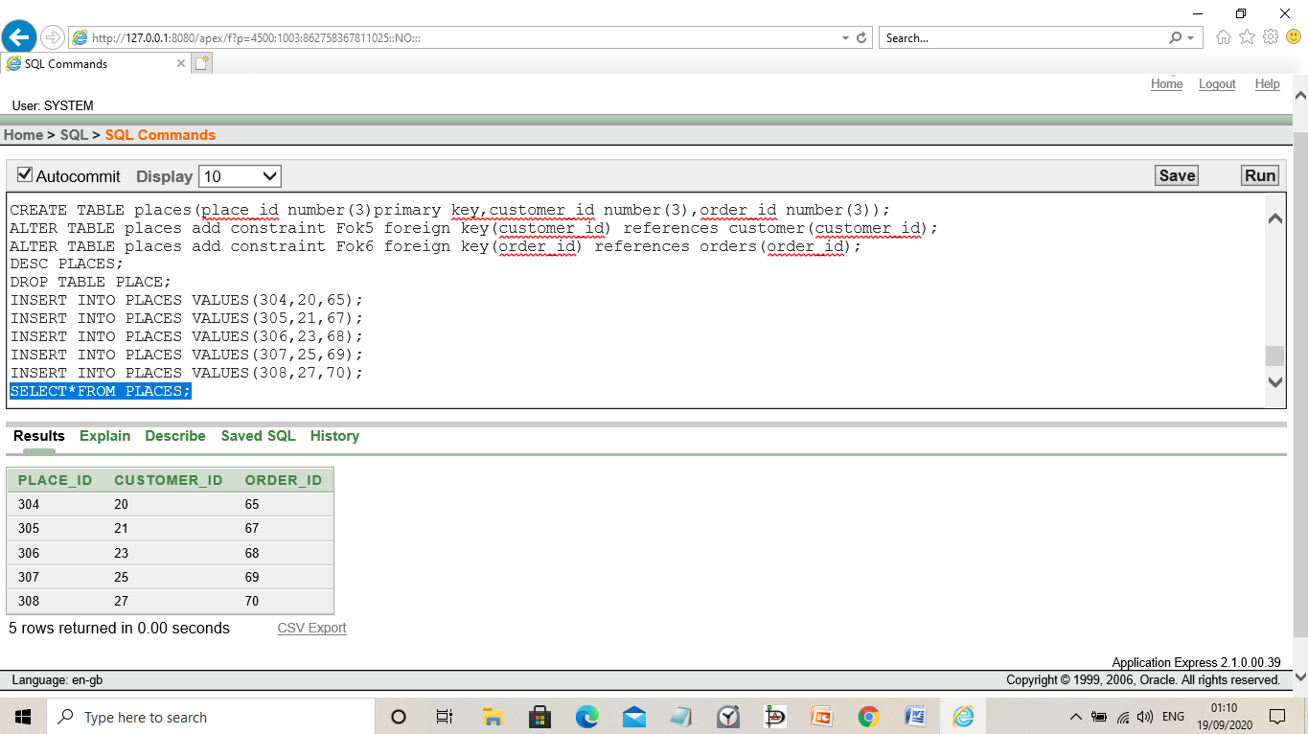

7. CREATE TABLE food_item(food_id number(3) primary key, price number,no_of_items number(5));

DESC FOOD_ITEM;

INSERT INTO FOOD_ITEM VALUES(94,345,3);

INSERT INTO FOOD_ITEM VALUES(95,645,4);

INSERT INTO FOOD_ITEM VALUES(96,299,3);

INSERT INTO FOOD_ITEM VALUES(97,35,5);

INSERT INTO FOOD_ITEM VALUES(98,896,9);

SELECT*FROM FOOD_ITEM;

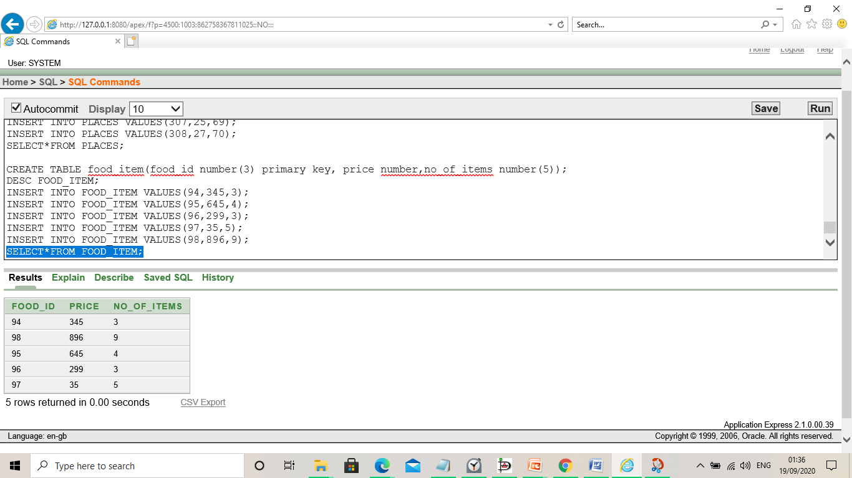

8. CREATE TABLE has(h_id number(3),order_id number(3),food_id number(3));

ALTER TABLE has add constraint Fok7 foreign key(order_id) references orders(order_id);

ALTER TABLE has add constraint Fok8 foreign key(food_id) references food_item(food_id);

DESC HAS;

INSERT INTO HAS VALUES(29,65,94);

INSERT INTO HAS VALUES(30,67,95);

INSERT INTO HAS VALUES(31,68,96);

INSERT INTO HAS VALUES(32,69,97);

INSERT INTO HAS VALUES(33,70,98);

SELECT*FROM HAS;

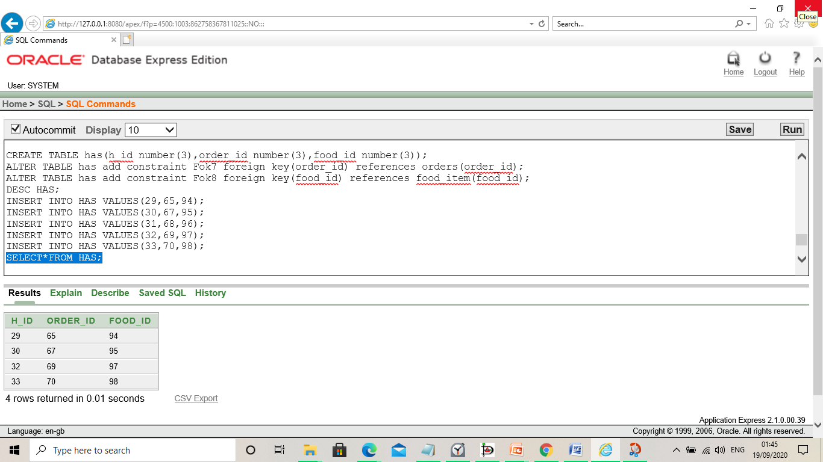

9. CREATE TABLE Restaurant(R_id number(3)primary key,name varchar(15),address varchar(20),email varchar(20),Restaurant_phonenumberid number(3));

ALTER TABLE Restaurant add constraint Fok9 foreign key(Restaurant_phonenumberid) references Restaurant_phonenumber(Restaurant_phonenumberid);

INSERT INTO Restaurant VALUES(223,'OLIVER','KHILGAON','oliver99@gmail.com',311);

INSERT INTO Restaurant VALUES(224,'Al-fresco','dhanmondi','fresco97@gmail.com',312);

INSERT INTO Restaurant VALUES(225,'burgerking','bshundhara','king99@gmail.com',313);

INSERT INTO Restaurant VALUES(226,'KFc','gulshan','kfc99@gmail.com',314);

INSERT INTO Restaurant VALUES(227,'Bfc','shantinagor','bfc99@gmail.com',315);

select*from Restaurant;

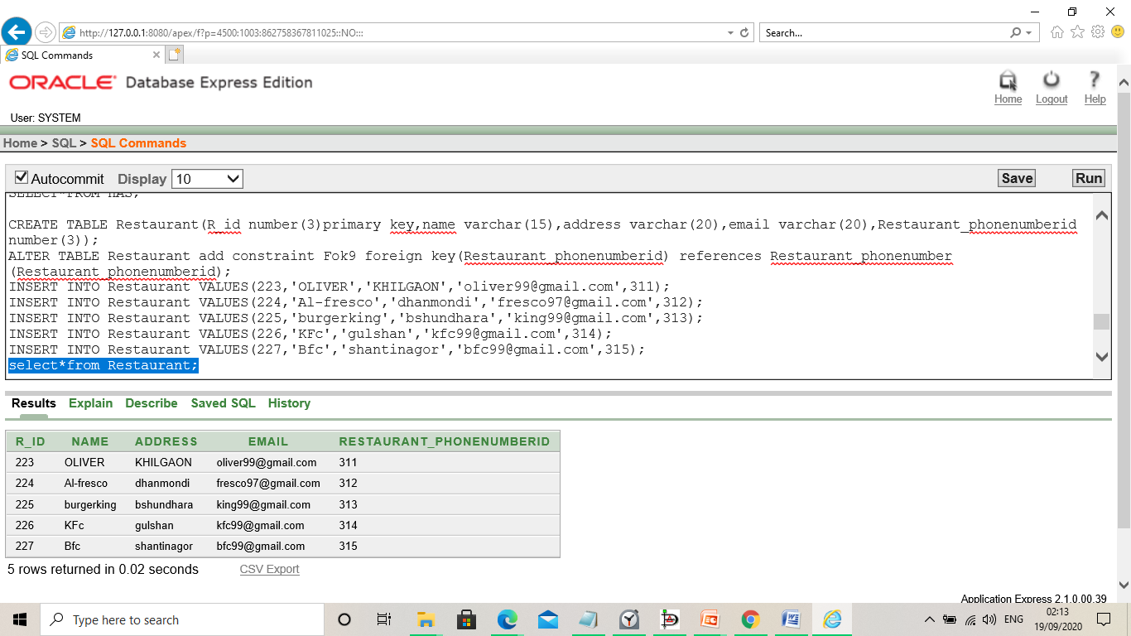

10. CREATE TABLE Restaurant_phonenumber(Restaurant_phonenumberid number(3)primary key, Restaurant_phonenumber number);

INSERT INTO Restaurant_phonenumber VALUES(311,01991236753);

INSERT INTO Restaurant_phonenumber VALUES(312,01891236753);

INSERT INTO Restaurant_phonenumber VALUES(313,01591236753);

INSERT INTO Restaurant_phonenumber VALUES(314,01691236753);

INSERT INTO Restaurant_phonenumber VALUES(315,01391236753);

select*from Restaurant_phonenumber ;

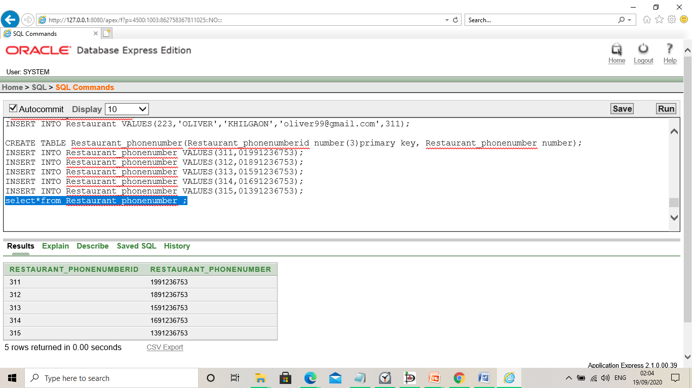

11. CREATE TABLE chooses(choose_id number(3)primary key,customer_id number(3),R_id number(3));

ALTER TABLE chooses add constraint Fok10 foreign key(customer_id) references customer(customer_id);

ALTER TABLE chooses add constraint Fok11 foreign key(R_id) references Restaurant(R_id);

insert into chooses values(291,20,223);

insert into chooses values(292,21,224);

insert into chooses values(293,23,225);

insert into chooses values(294,25,226);

select*from chooses;

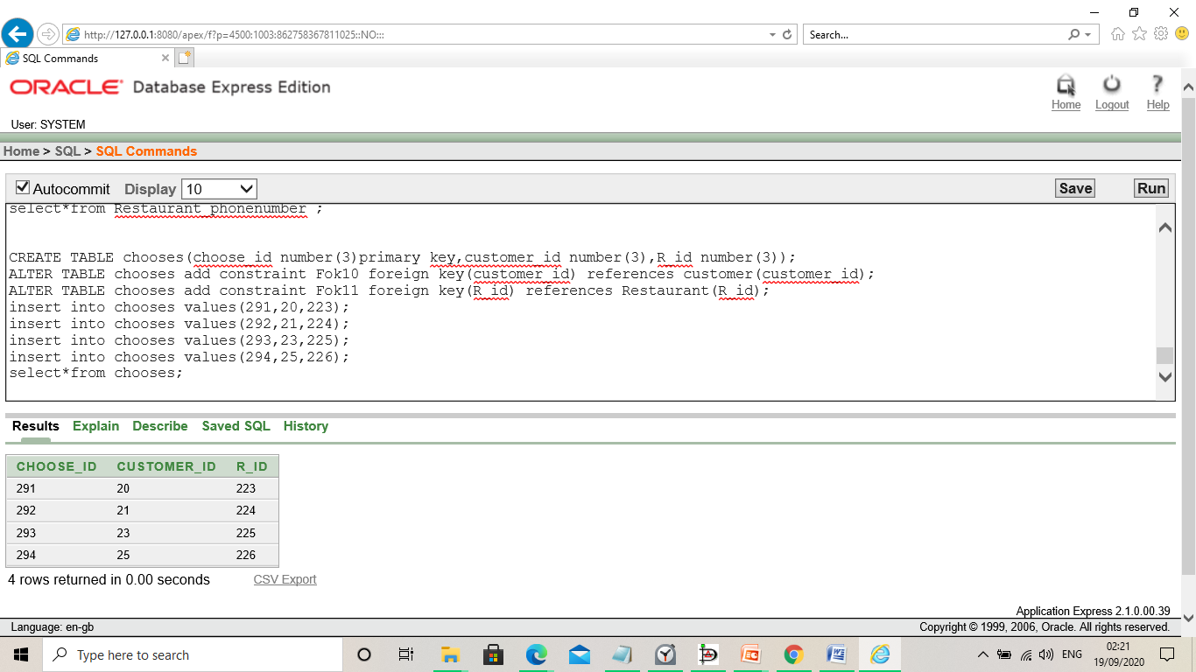

12. CREATE TABLE gets(get_id number(3)primary key,R_id number(3), order_id number(3));

ALTER TABLE gets add constraint Fok12 foreign key(R_id) references Restaurant(R_id);

ALTER TABLE gets add constraint Fok13 foreign key(order_id) references orders(order_id);

insert into gets values(401,223,65);

insert into gets values(402,224,67);

insert into gets values(403,224,68);

insert into gets values(404,225,69);

insert into gets values(405,226,70);

select*from gets;



13. CREATE TABLE delivery_boy(db_id number(3)primary key,name varchar(15),db_phonenumberid number);

ALTER TABLE delivery_boy add constraint Fok14 foreign key(db_phonenumberid) references deliveryboy_phonenumber(db_phonenumberid);

insert into delivery_boy VALUES(46,'MARTIN',723);

insert into delivery_boy VALUES(47,'LUCIFER',724);

insert into delivery_boy VALUES(48,'JACK',725);

insert into delivery_boy VALUES(49,'TOM',726);

insert into delivery_boy VALUES(50,'NICK',727);

select*from delivery_boy;

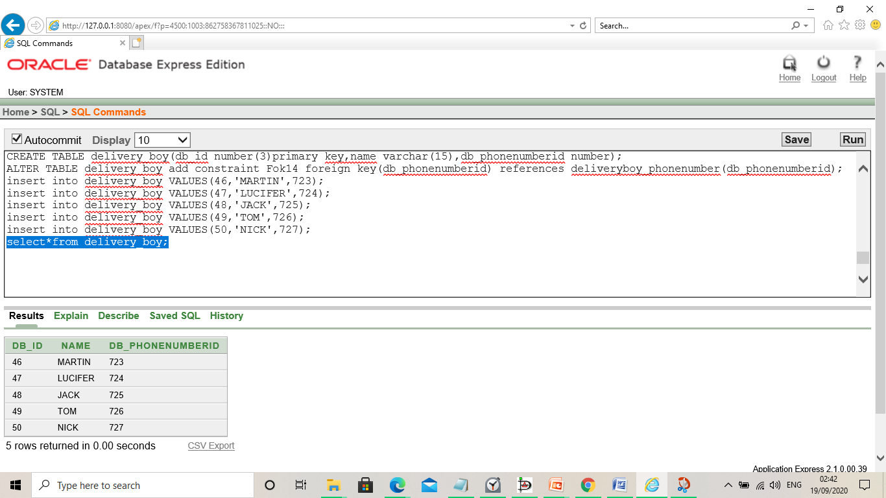

14. CREATE TABLE deliveryboy_phonenumber(db_phonenumberid number(3)primary key,db_phonenumber number);

insert into deliveryboy_phonenumber values(723,01712675436);

insert into deliveryboy_phonenumber values(724,01612675436);

insert into deliveryboy_phonenumber values(725,01912675436);

insert into deliveryboy_phonenumber values(726,01312675436);

insert into deliveryboy_phonenumber values(727,01512675436);

select*from deliveryboy_phonenumber ;

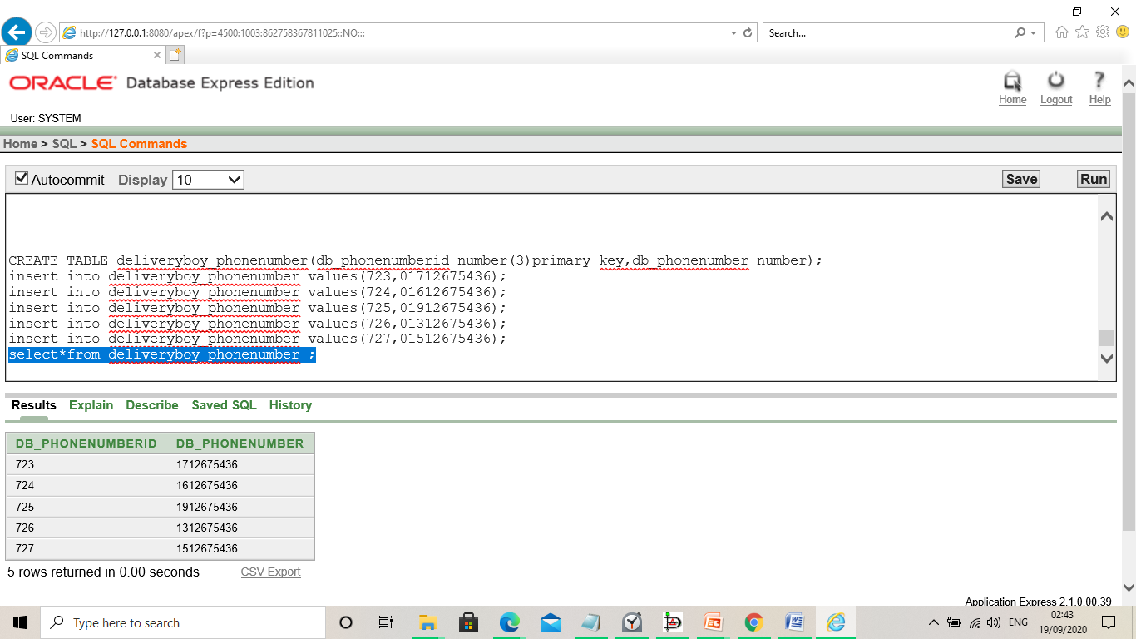

15. CREATE TABLE hires(hires_id number(3)primary key,db_id number(3), r_id number(3));

ALTER TABLE hires add constraint Fok15 foreign key(db_id) references delivery_boy(db_id);

ALTER TABLE hires add constraint Fok16 foreign key(R_id) references Restaurant(R_id);

INSERT INTO HIRES VALUES(501,46,223);

INSERT INTO HIRES VALUES(502,47,224);

INSERT INTO HIRES VALUES(503,48,225);

INSERT INTO HIRES VALUES(504,49,226);

INSERT INTO HIRES VALUES(505,50,227);

SELECT*FROM HIRES;

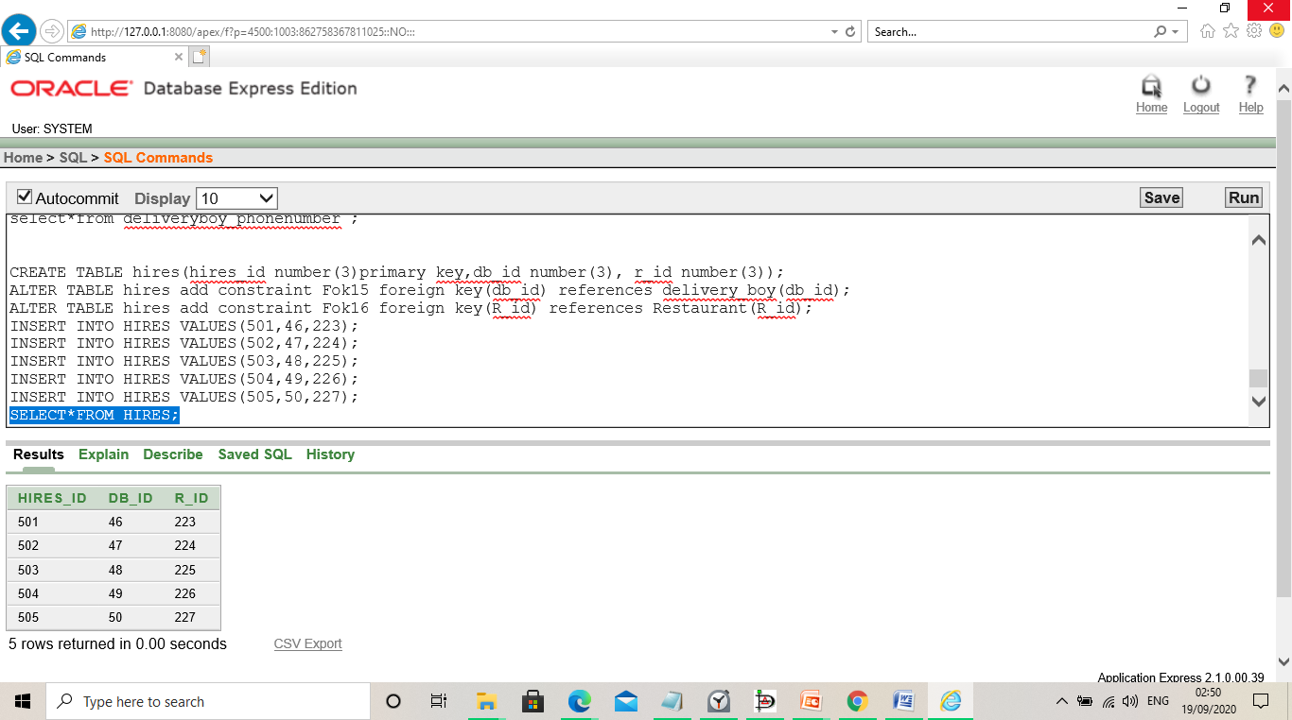

16. CREATE TABLE delivers(deliver_id number(3)primary key, db_id number(3), food_id number(3));

ALTER TABLE delivers add constraint Fok17 foreign key(db_id) references delivery_boy(db_id);

ALTER TABLE delivers add constraint Fok18 foreign key(food_id) references food_item(food_id);

INSERT INTO DELIVERS VALUES(701,46,94);

INSERT INTO DELIVERS VALUES(702,47,95);

INSERT INTO DELIVERS VALUES(703,48,96);

INSERT INTO DELIVERS VALUES(704,49,97);

INSERT INTO DELIVERS VALUES(705,50,98);

SELECT*FROM DELIVERS;

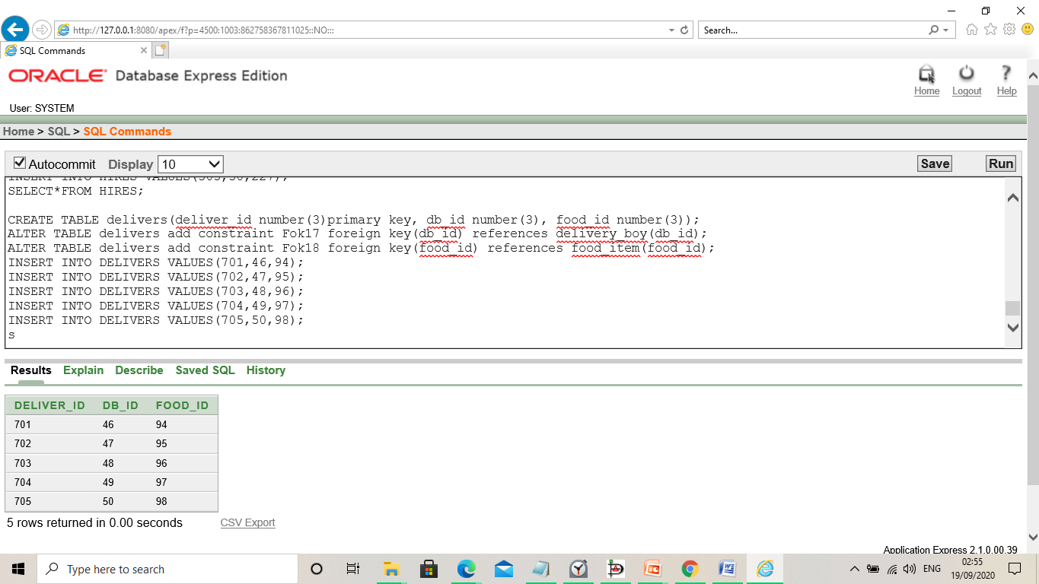

**QUERY WRITING:**

**VIEW:**

* + Create a view, R_ID223, that contains details of RESTAURANT in R_ID.

select*from Restaurant;

create view R_id223 as select name,address,restaurant_phonenumberid from Restaurant where R_id=223;

describe R_id223;

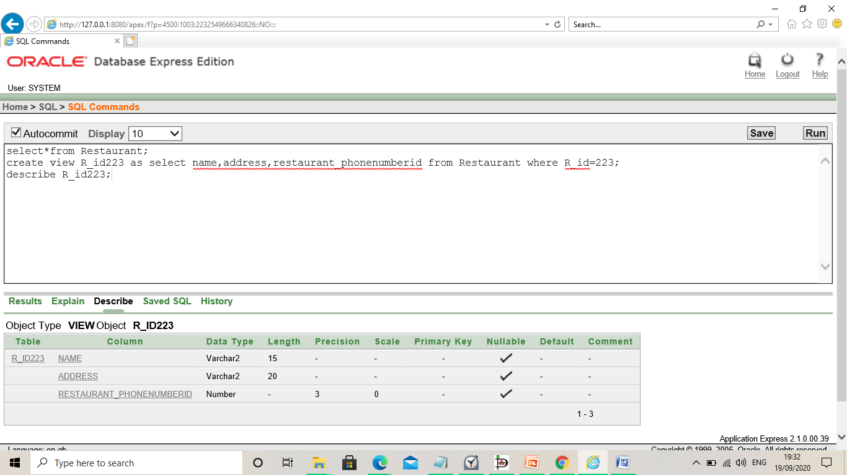

Create a view, ORDER_ID, that contains details of ORDERS in order_id?

SELECT*FROM ORDERS;

CREATE VIEW ORDER_ID70 AS SELECT NO_OF_ITEM,TOTAL_BILL,DELIVERY_PHONENUMBER_ID FROM ORDERS WHERE ORDER_ID=69;

DESCRIBE ORDER_ID70;

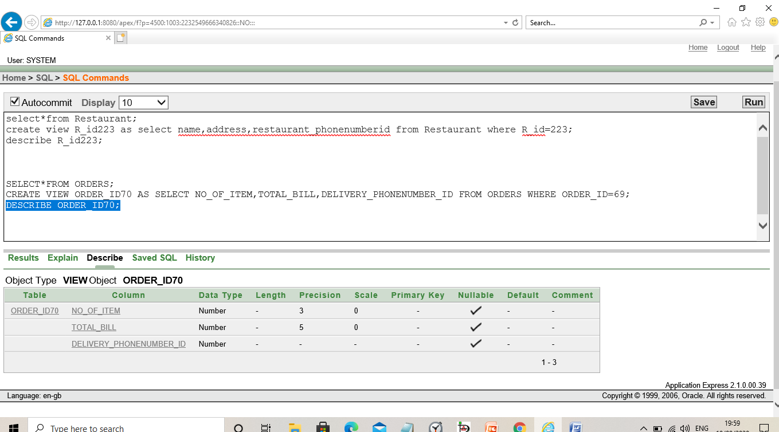

**JOINING:**

SELECT*FROM CUSTOMER;

SELECT*FROM PAYS;

SELECT CUSTOMER.CUSTOMER_ID,CUSTOMER.NAME,CUSTOMER.CUSTOMER_PHONENUMBERID,PAYS.PAYS_ID,PAYS.CUSTOMER_ID FROM CUSTOMER,PAYS WHERE CUSTOMER.CUSTOMER_ID=PAYS.CUSTOMER_ID;

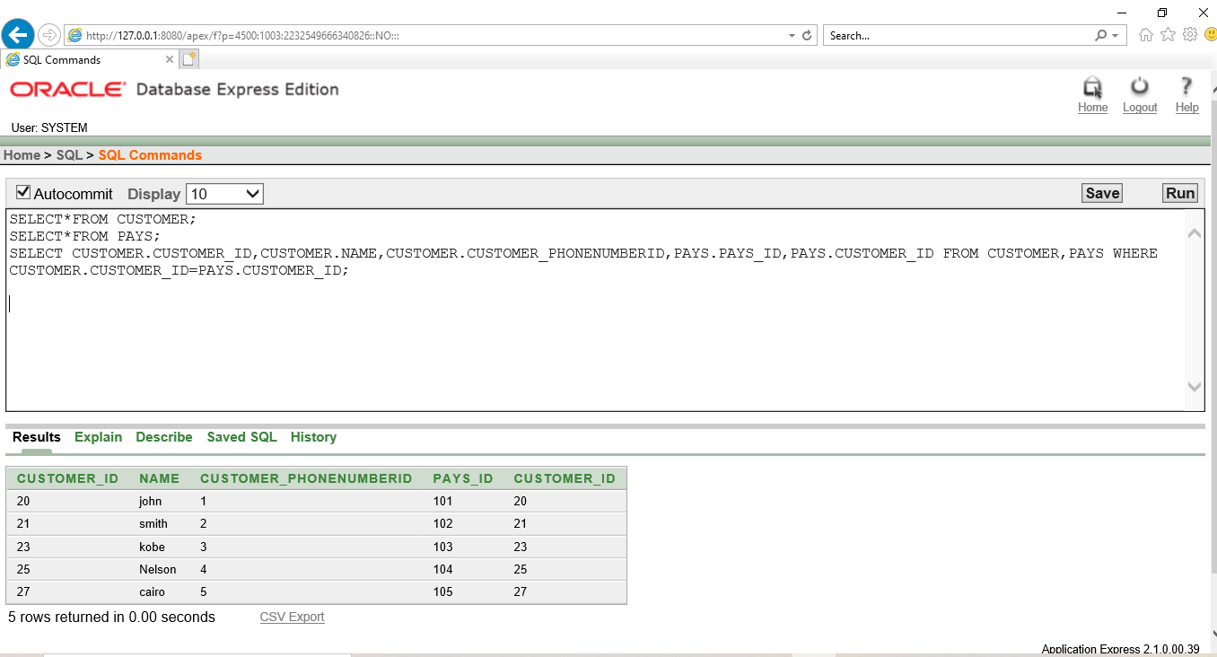

SELECT*FROM BILL_PAYMENT;

SELECT*FROM PAYS;

SELECT BILL_PAYMENT.BILL_ID,BILL_PAYMENT.CASH_ON_DELIVERY,PAYS.BILL_ID,PAYS.PAYI D FROM BILL_PAYMENT,PAYS WHERE BILL_PAYMENT.BILL_ID=PAYS.BILL_ID;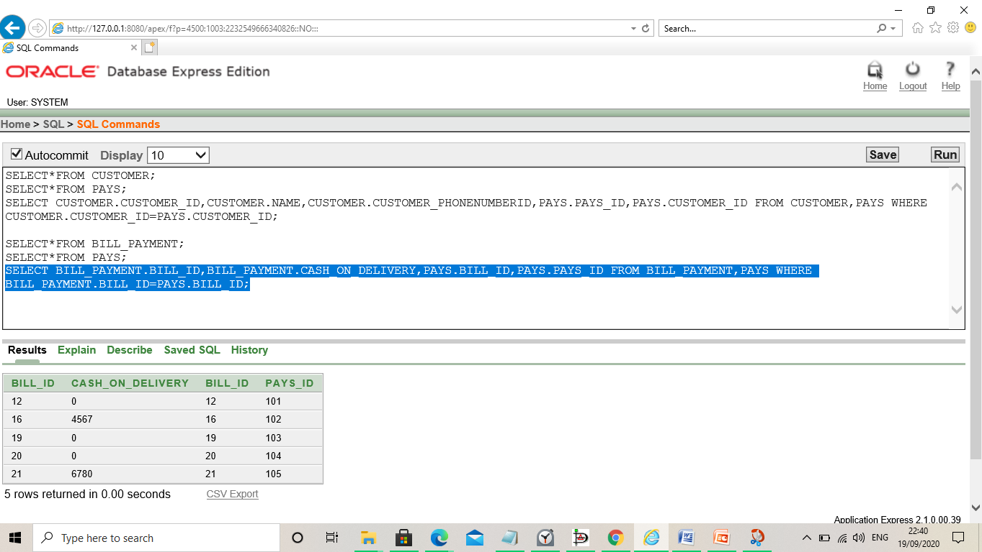

**SUBQUERY:**

Select * from Bill_payment where Cash_On_Delivery < ANY( select Cash_On_Delivery from Bill_payment where BILL_Id='16') AND BILL_ID <> '16';

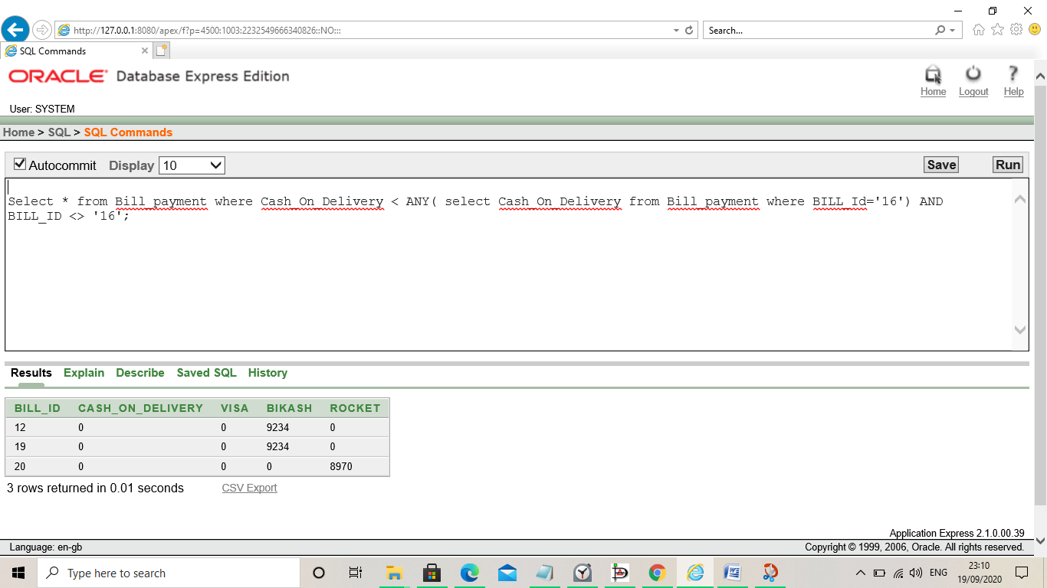

**Relational Algebra:**

1.Find the delivery id where food id is 94?

∏*delivery_id*(σ*food_id* = “94” (*Delivery*))

2. Find food id and db id where delivery id is 785?

∏*db_id,food_id* (σ*delivery_id*=“785” (*Delivery))*

3. Find the DB id and phone number id of Delivery boy Martin?

∏*db_id,phone_number* (σ*name*=“martin” (*Deliveryboy*))

4. Find Restaurant id of hire id 544?

∏*resturant_id* (σ*hire_id*=“544” (*Hires*))

5. Find Hire id of restaurant id 226?

∏*hire_id* (σ*restaurant_id*=“226” (*Hires*))

**CONCLUSION:**

Food Delivery Management System is a web based application that stimulates the foodies (customers) to put food orders through internet by locating their favorite restaurants as nearest ones.

The project gave us the opportunity to try our new skills in practice. While doing this project we also gained deeper understanding on database design. Careful planning and learning your users’ need clarifies a lot of important cornerstones.

User requirements keep changing as the system is being used. Some of the future enhancements that can be done to this system are:

* Based on the future security issues, security can be improved using emerging technologies.
* Allow to save payment details for future use.
* Send an Order Ready notification to the customer.
* Allow to process an order as a Guest.